Interrupt assignment
Technical Report

Author: Miroslav Denkov
Student number: 524298

Introduction

This report outlines the methods and execusion of the first assignment for the Semester3-ES class. The task is to understand bare-metal GPIO programming on the Nucleo F303RE microcontroller.

The requirements are the following:
- Connect two buttons and two LEDs
- When pressing the first button, it must toggle its corresponding LED.
- When the second button is pressed, the other LED lights up and turns off after the button is released.
- The last task is to create something fun. I used the idea of connecting a rotary encoder and making a counter

Build design

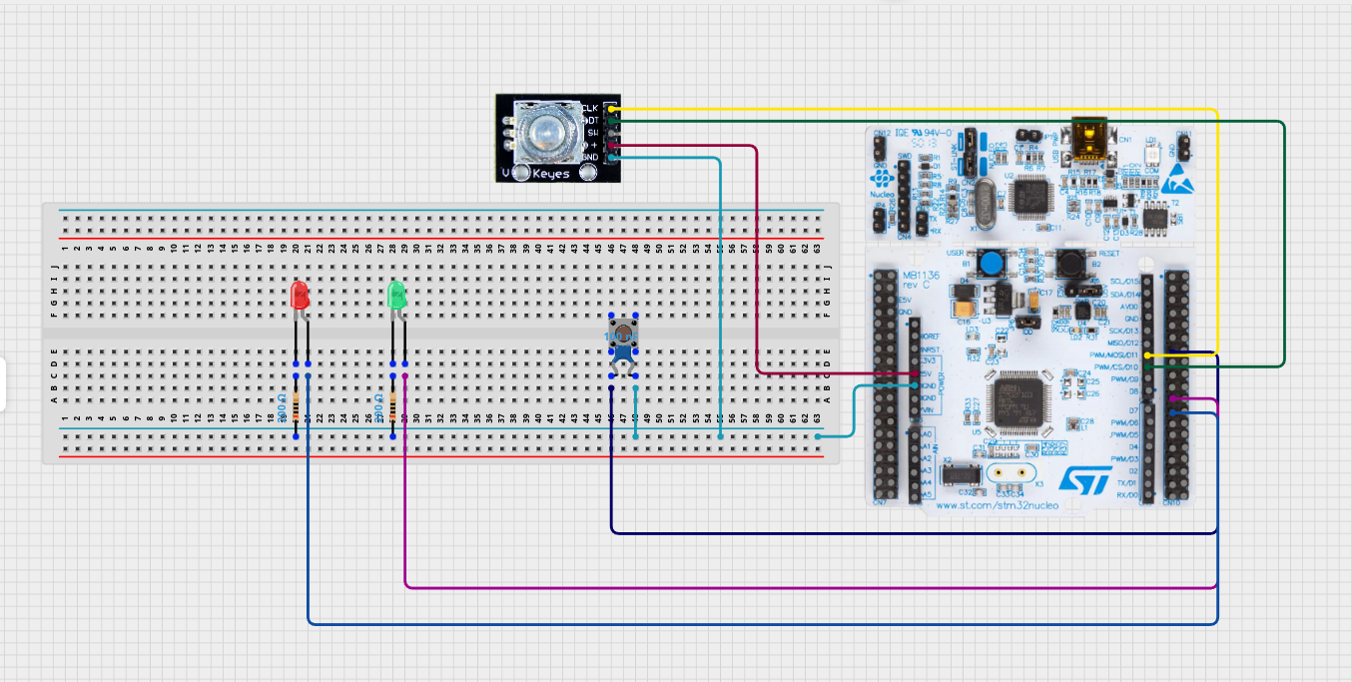
Code Design

On a high-level, the green LED is handled in the traditional way, with polling. In the loop we constantly check if the button is pressed or released and we act accordingly. The red led(which is toggled) is handled by an Interrupt Service routine, as well as the rotary encoder logic. Therefore it doesn’t matter what the CPU is doing, on a button press the LED toggles and when engaged, the rotary encoder counts.

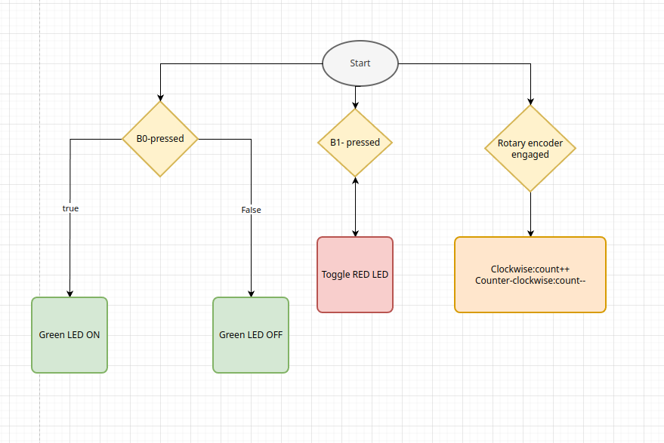

Evidence:

Turning PA9 on and, upon release, off.

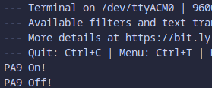

Toggling PA8 with an interrupt.



Rotary encoder count:

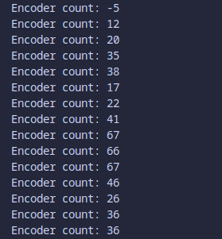

Issue: The encoder’s readings seem to be chaotic. As of writing this document I have not yet found a solution on the issue.

